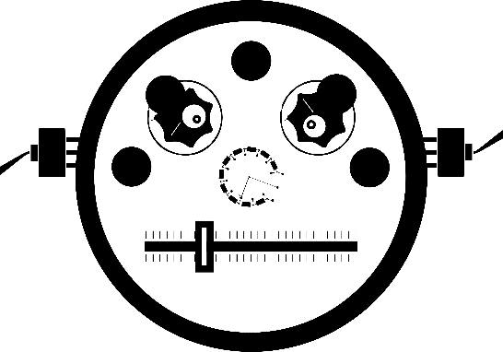**SD2IEC Tic Tac**

1.1

* https://github.com/gh0stless/SD2IEC-Tic-Tac-Edition

### info@crazy-midi.de